**SB8056 – DIGITAL MARKETING**

**PROJECT: BUILDING A WEBSITE USING CANVA**

**TEAM ID: NM2023TMID04457**

**TEAM LEADER: YUVASRI K (731120106044)**

**TEAM MEMBER 1: VIMAL PRIYA M (731120106041)**

**TEAM MEMBER 2: VARSHA DEVI N (731120106038)**

**TEAM MEMBER 3: NANDHINI J (731120106018)**

STEP BY STEP OF PROJECT IMPLEMENTATION

Here is the step-by-step guide to creating a website for a book cafe using Canva.

**Step 1: Set Up Your Canva Account**

Navigate to <http://www.canva.com/> and sign in or create a new account that is created for your brand.

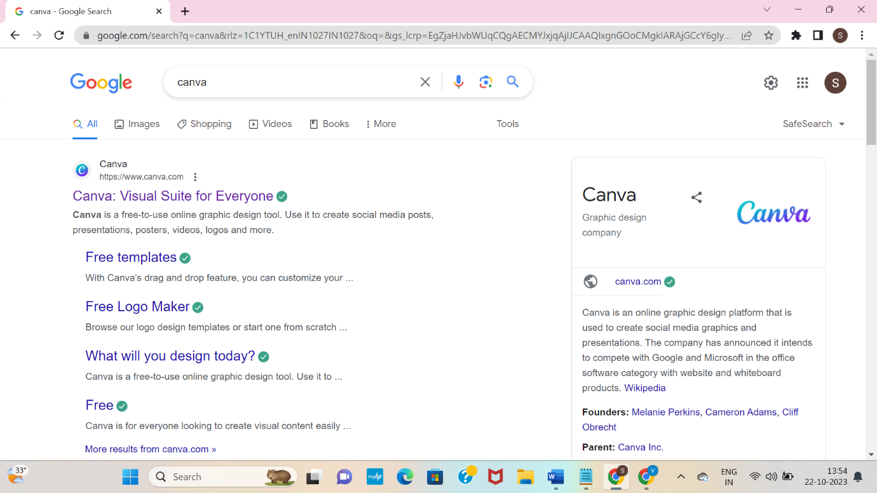

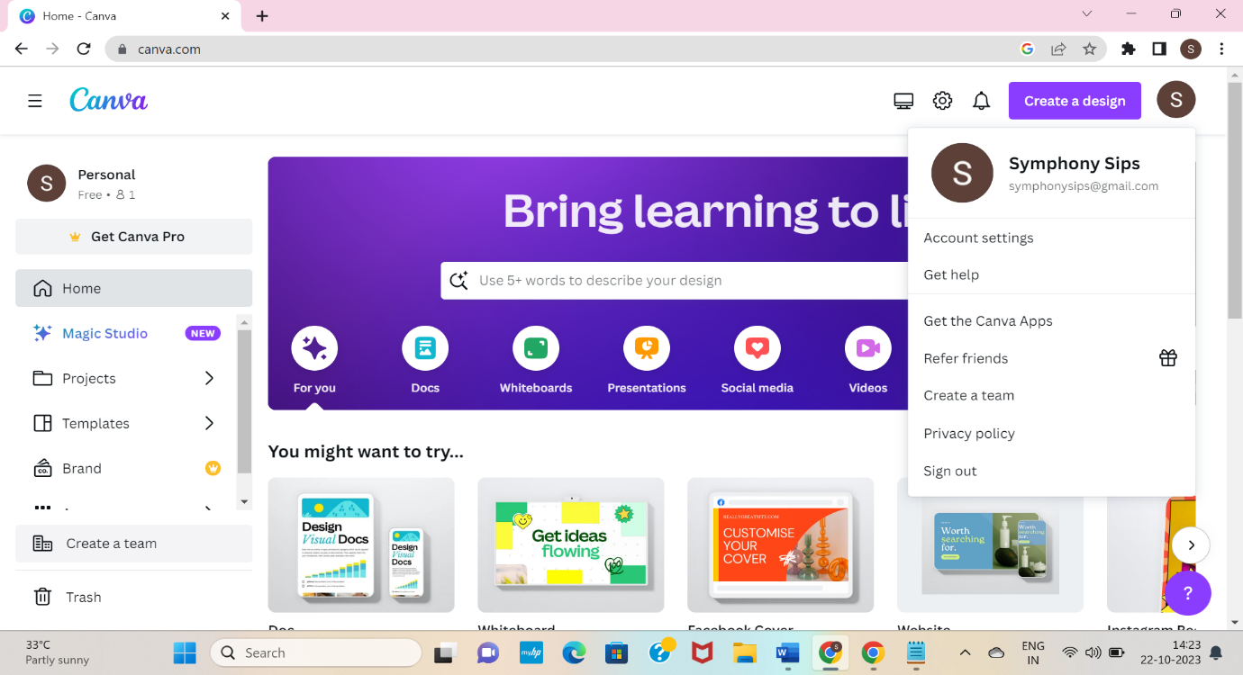

**Step 2: Click the Create Design.**

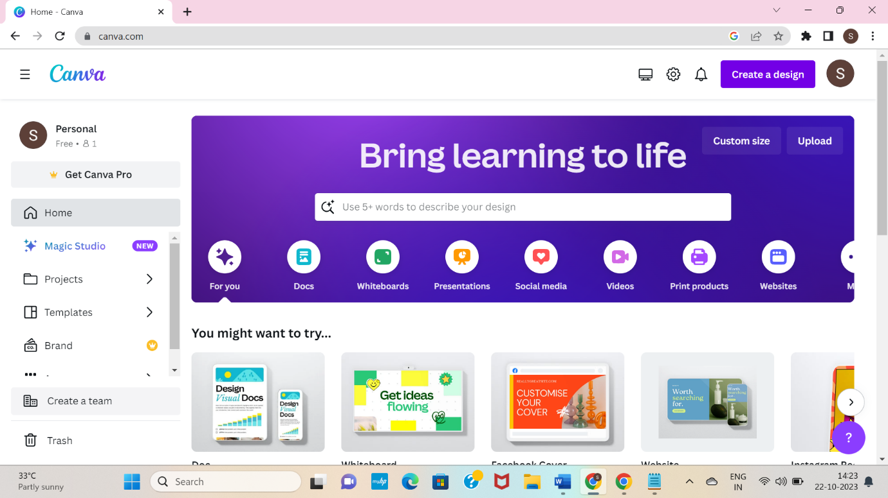

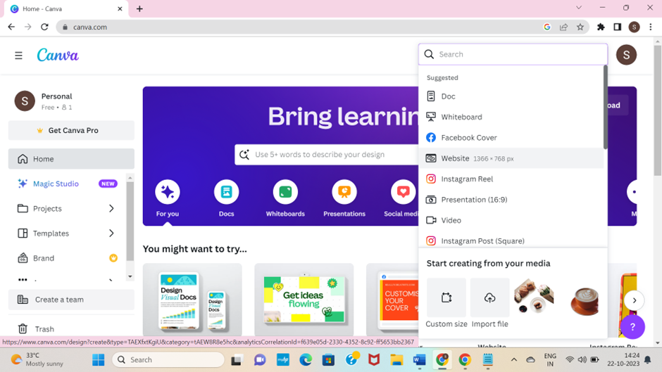

**Step 3: Search and Click ‘Website’**



**Step 4: Search and Click ‘Online Store’, choose the design according to the brand**.

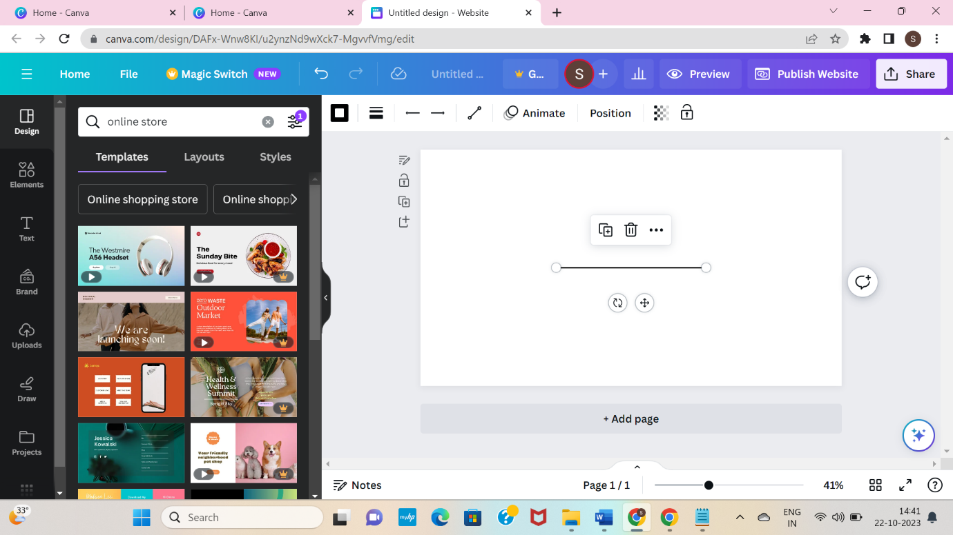

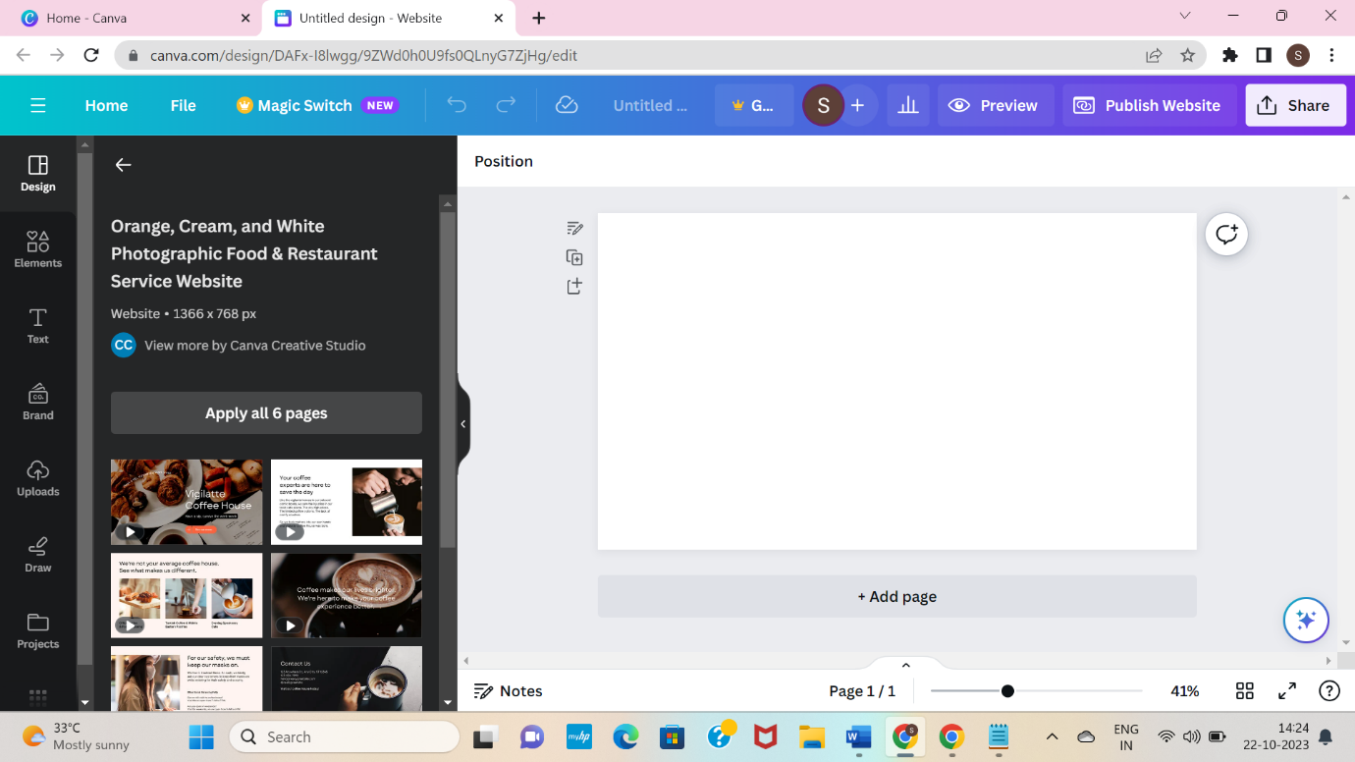

**Step 5: After choosing the template, change the background and start editing it.**

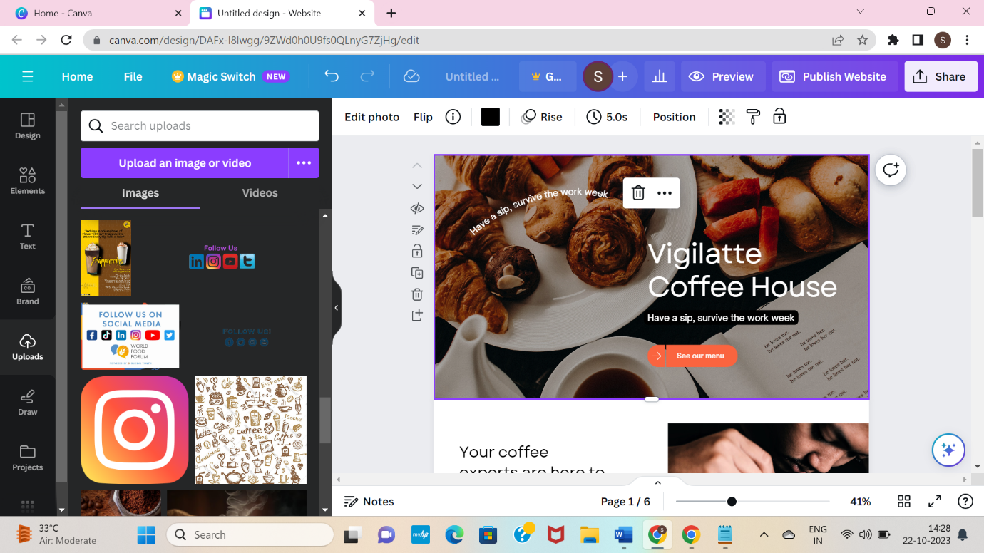

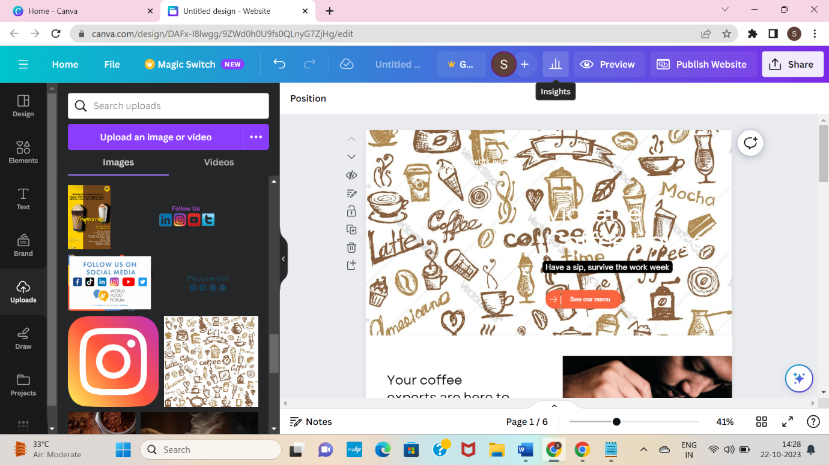

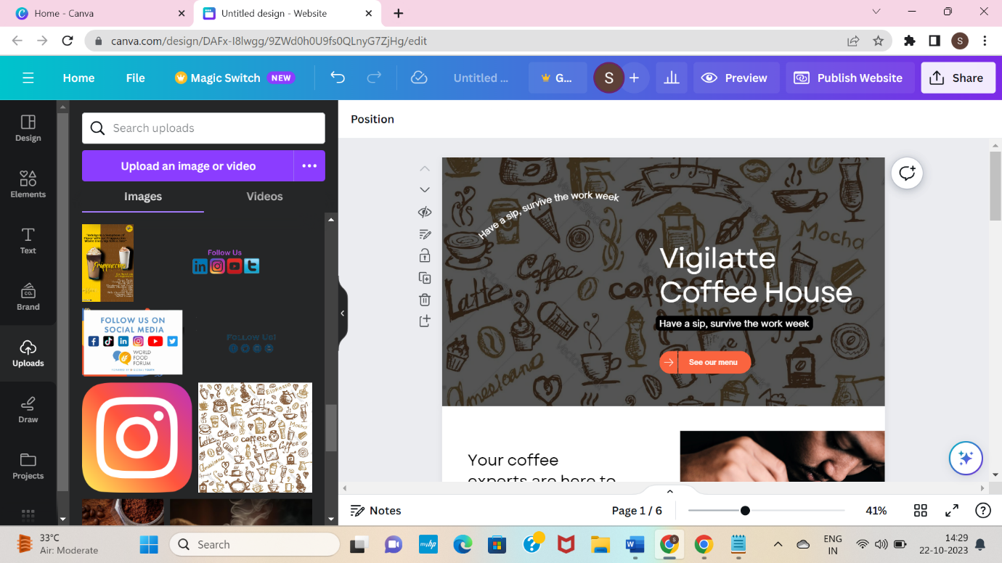

**Step 6: Add the title of the brand to the selected design.**

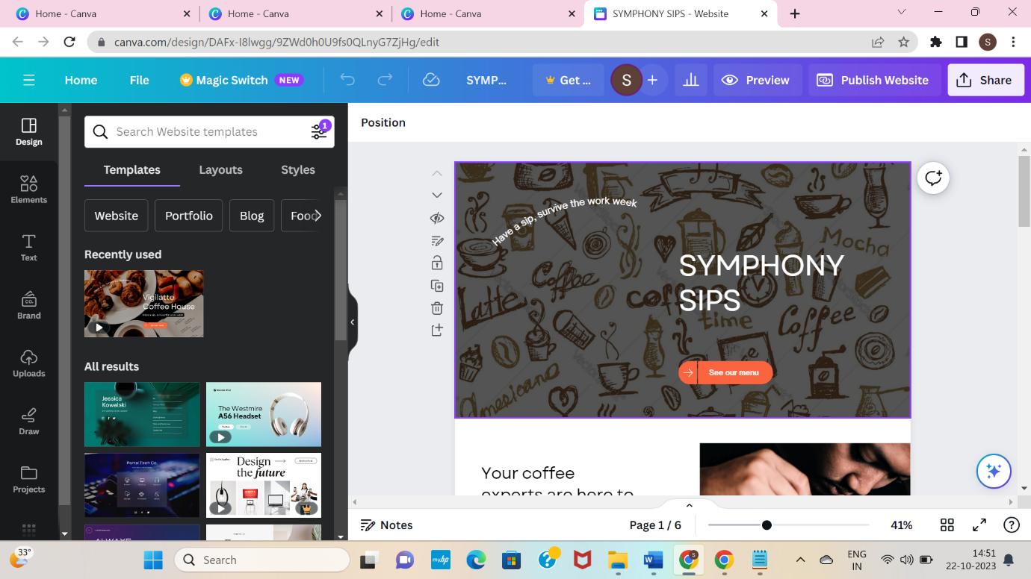

**Step 7: After finishing the editing, publish your website. Before publishing it see the preview, customize the URL and publish it.**

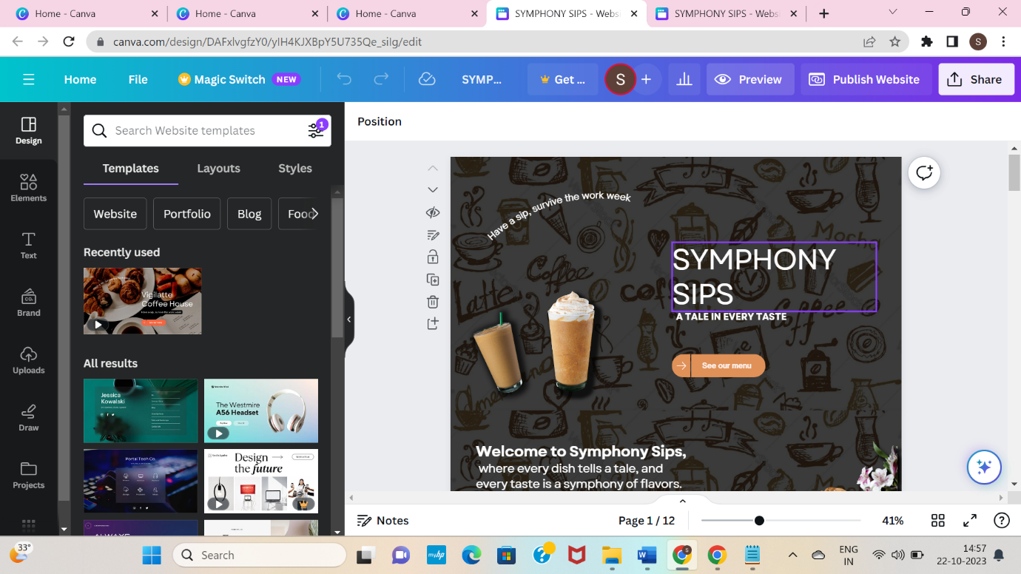

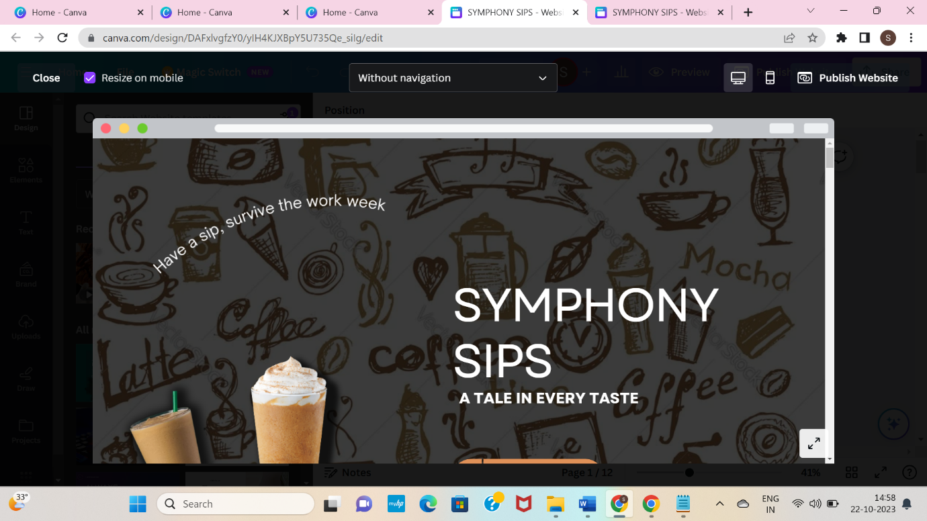

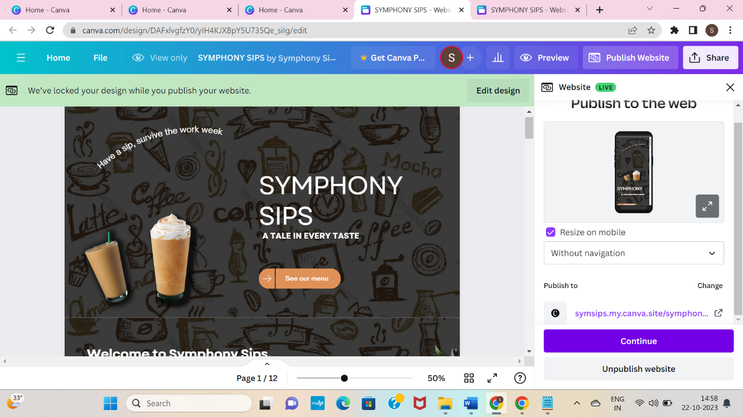

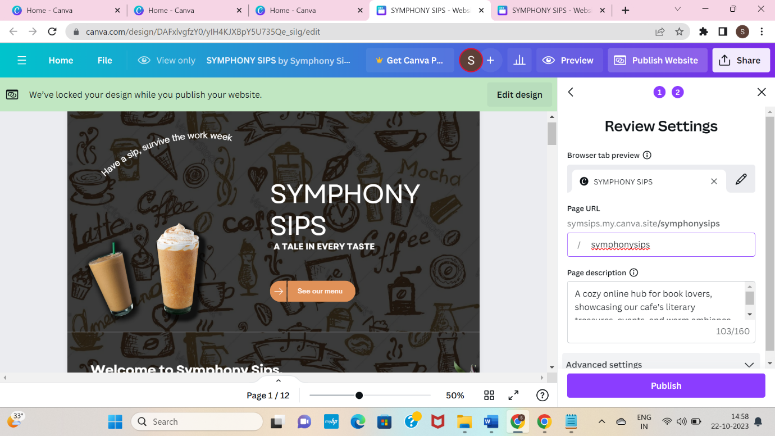

**Step 8: Click Publish and view the created website.**

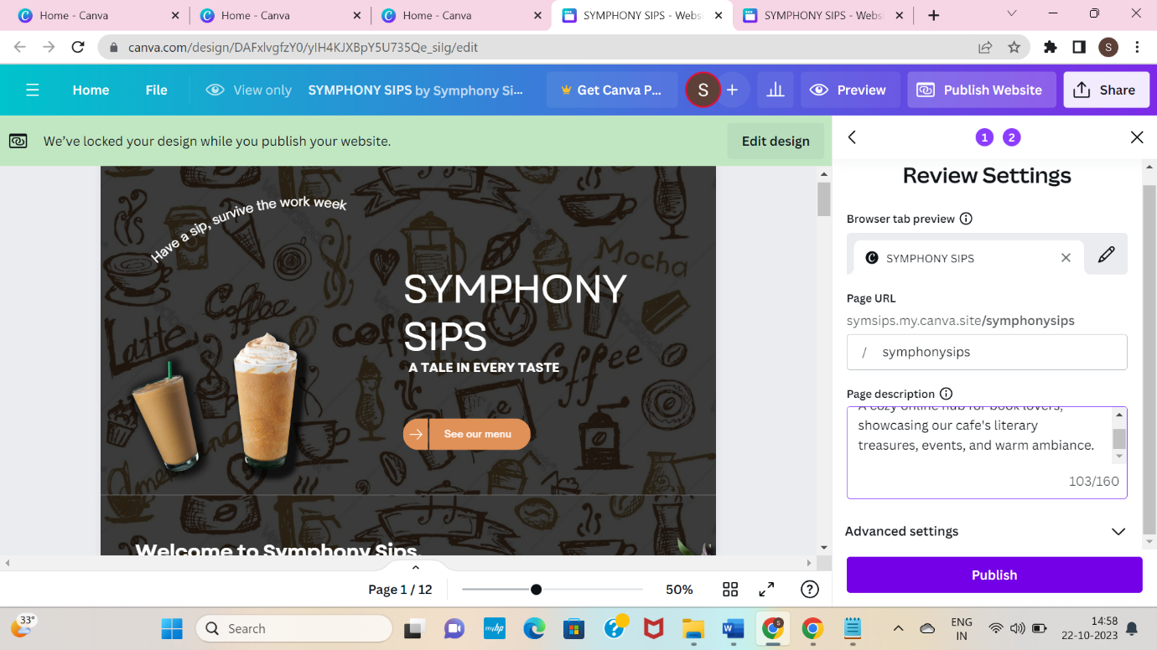

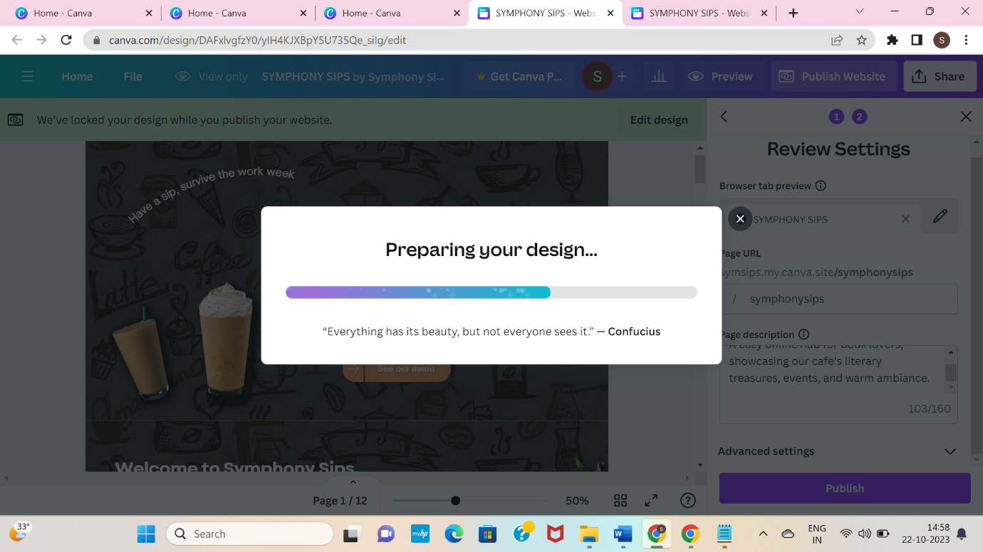

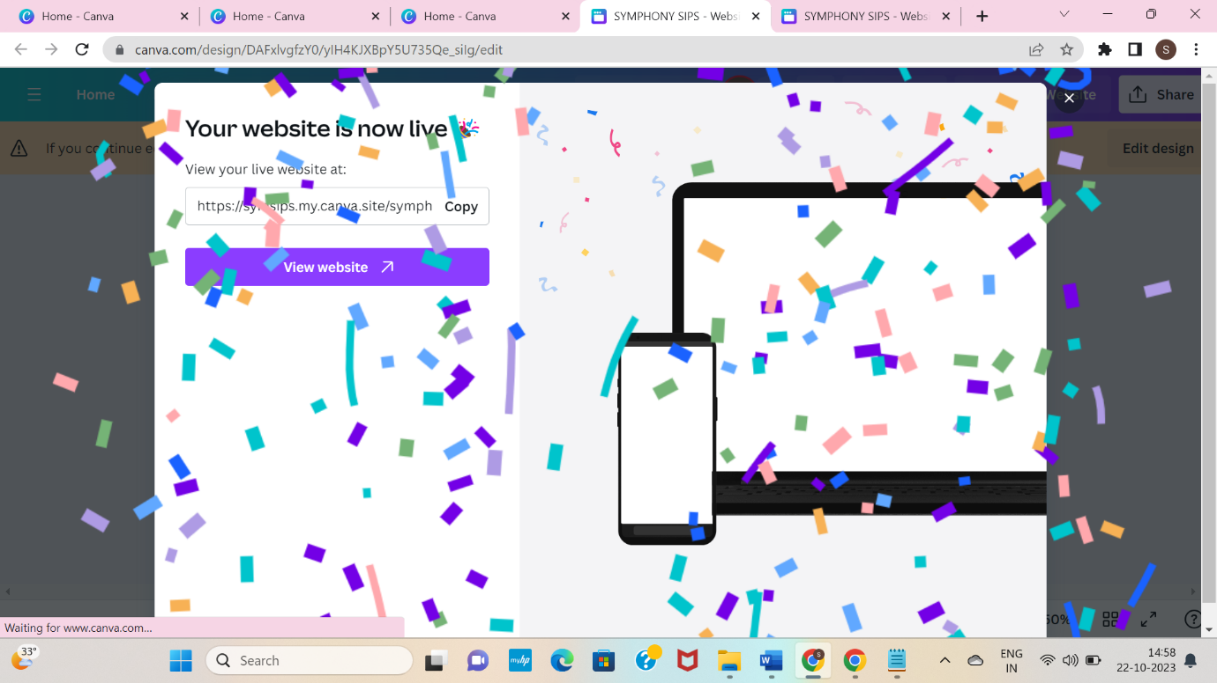

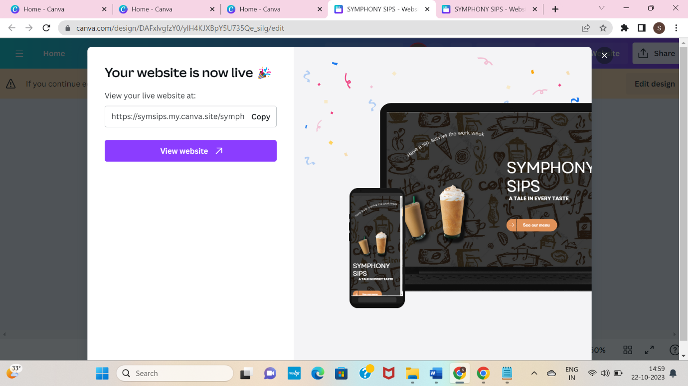

**WEBSITE LINK:**

<https://symsips.my.canva.site/symphonysips>

